**DATA FLOW DIAGRAM**

Machine Learning-Based Predictive Analytics for Aircraft Engine

|  |
| --- |
|  |
|  |

DATA PROCESS

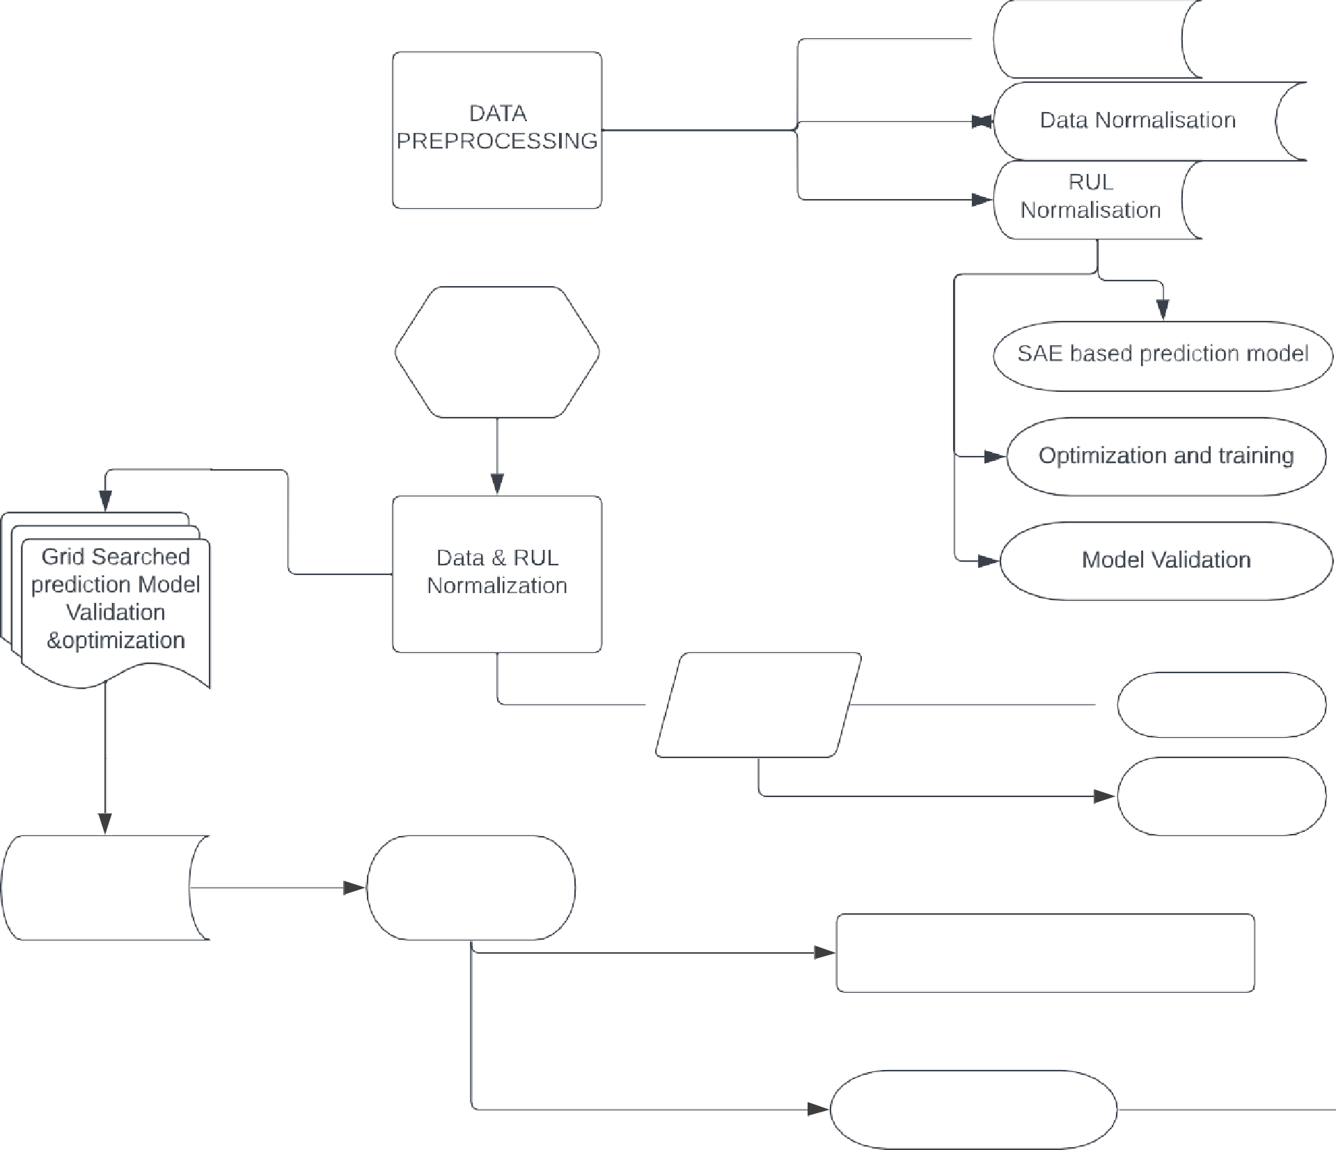

>- Sensor Selection

HISTORICAL DATA

”

Sensor Selection

Sparse Auto

” Encoder

p- Denoising Encoder

Building Stacked noise Encoder

Training Testing

Description of Engine Data

Results And Description

Optimization Using GRID search

CONCLUSON